SURPRISE TEST
FULL MARKS- 10

- Choose the correct option –

- Three students performed an investigation on different food samples:
Statement 1: Riya added a few drops of a particular solution to a piece of boiled gram. The food sample does not turn blue-black.
Statement 2: Aman added the same solution to a sugar solution. No blue-black colour appeared.
Statement 3: Sara added the same solution on a piece of fish. It doesn’t turned blue-black.
Suddenly a few drops of the same solution fell on the teacher’s saree and it turned blue-black.
Why did the teacher’s saree turn blue-black?

- The saree contained protein, which reacted with iodine to produce a blue-black colour.
- The colour of the saree changed because iodine reacts with all food substances.
- The saree contained sugar, which produced a blue-black colour with iodine.
- The saree contained starch, which reacted with iodine to produce a blue-black colour.

- Statement 1: The pine tree in the Himalayas has sloping branches.
Statement 2: The polar bear in the cold desert has a thick coat of hair.

- They help the organisms cope with the harsh environmental conditions of their habitats.
- They help both organisms obtain more food from their surroundings.
- They help both organisms to cope up with the hibernation in their habitats.
- They help both organisms move faster to escape from predators.

- Among the following, which is/are the correct statement(s)?
Statement 1: SI units provide a common standard for measurement, making measurements easier to compare worldwide.
Statement 2: Using SI units reduces confusion caused by different units being used for the same physical quantity.
Statement 3: A measurement can be scientifically compared with another measurement even if both are expressed in different units without conversion.
Statement 4: SI units are used only in science laboratories and are not useful in everyday measurements.
Choose the correct option:
- Statements 1 and 3 only
- Statements 1 and 2 only
- Statements 1, 2 and 3 only
- All four statements
- Assertion (A): A maize plant possesses leaves with reticulate venation and a fibrous root system.
Reason (R): All monocotyledonous plants have leaves with parallel venation and a bunch of fibrous root.

- Both A and R are true, and R is the correct explanation of A.
- Both A and R are true, but R is not the correct explanation of A.
- A is true, but R is false.
- A is false, but R is true.

- While exploring a nature park, Rohan finds two small creatures hiding under a fallen log.
Creature X has a soft, segmented body, moves by stretching and contracting, and leaves behind a trail of moist soil.
Creature Y has a hard outer covering, three pairs of legs, and a pair of antennae. It moves quickly when disturbed.
Which of the following correctly compares Creature X and Creature Y?

- X is a vertebrate because its body is segmented, while Y is an invertebrate because it has an outer covering.
- X and Y are both vertebrates because both can move independently.
- X and Y are both invertebrates because neither has a backbone; however, they belong to different groups based on their body features.
- X is an invertebrate, but Y is a vertebrate because Y has a hard outer covering.

- Rihana is making a model of the solar system for her science project. She has a wire of length 1.5 m and wants to cut it into equal pieces of 6 cm each. How many complete pieces can she make, and how much wire will be left?

- 20 pieces, 30 cm left
- 25 pieces, no wire left
- 25 pieces, 5 cm left
- 30 pieces, no wire left

- Avi wants to magnetise a steel needle using a bar magnet. He repeatedly moves the same pole of the bar magnet over the needle in the same direction, lifting the magnet after each stroke and bringing it back to the starting point without rubbing it backwards. Why is this method effective?

- Repeated strokes in the same direction help the magnetic domains in the steel needle become more aligned.
- Rubbing the magnet back and forth randomly makes all magnetic domains disappear.
- The steel needle becomes magnetic simply because it is made of metal.
- The needle gets magnetised only because friction produces heat during stroking.
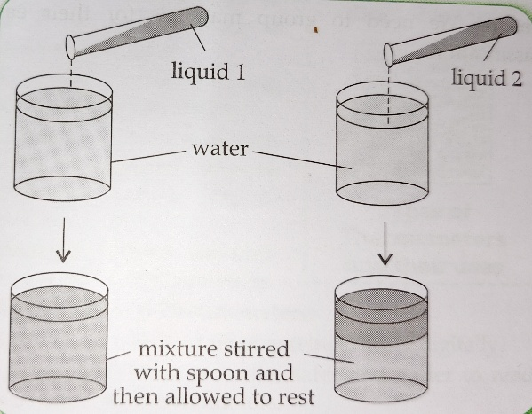
- Study the given picture carefully. Equal amounts of Liquid 1 and Liquid 2 are added separately to water, stirred with a spoon, and then allowed to rest. Which of the following statements is correct?
- Liquid 1 is insoluble in water because it forms a uniform mixture.
- Liquid 2 is completely soluble in water because some particles settle at the bottom and some mix uniformly.
- Liquid 1 forms a more uniform mixture, whereas Liquid 2 contains particles that settle after standing.
- Both Liquid 1 and Liquid 2 form exactly the same type of mixture.
- Which of the following statements are correct about periodic motion?
  - The motion repeats itself after equal intervals of time
  - The object returns to the same position after a fixed interval of time.
  - The motion must always be along a straight path.
  - The time taken for one complete repetition remains the same.

- i and ii only
- i, ii and iv only
- ii and iii only
- i, ii, iii and iv
- A piece of sedimentary rock is buried deep inside the Earth, where it experiences high temperature and pressure but does not melt. Later, it is brought closer to the surface and exposed to weathering and erosion. Which sequence of changes is most likely to occur?
- Sedimentary rock → Igneous rock → Sedimentary rock
- Sedimentary rock → Metamorphic rock → Magma
- Sedimentary rock → Magma → Igneous rock
- Sedimentary rock → Metamorphic rock → Sedimentary rock

